Bamazon Customer Code Examples:

Example of a purchase request with enough inventory in stock. Order is completed:

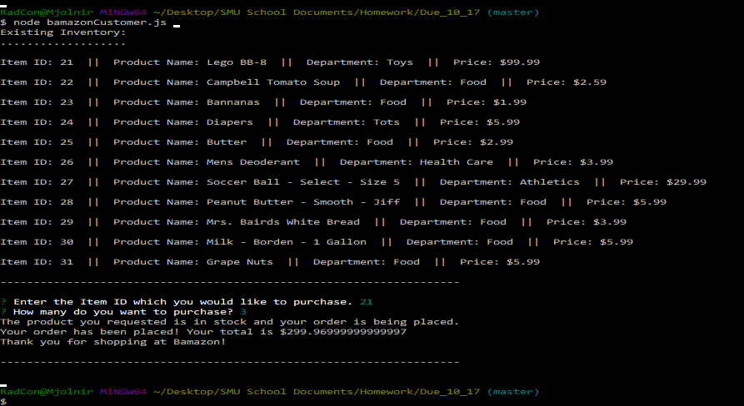

Example of a purchase with insufficient inventory in stock. Order does not complete and customer is asked to modify order:

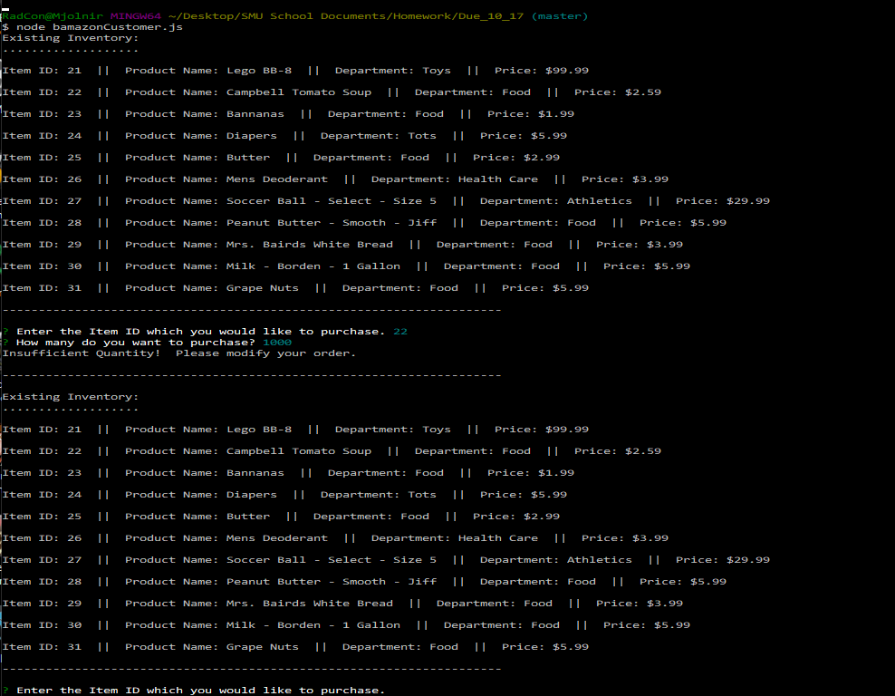

Example of a purchase with an incorrect Item ID. Order does not complete and customer is asked to enter an existing Item ID:

